
SVKM’s INSTITUTE OF TECHNOLOGY, DHULE
Department of Information Technology
Academic Year 2025-26

Experiment 4

Name: Bhupesh Anil Suryawanshi
Roll No.: 63
Batch: B3

Aim: Implement and test RBF network

Theory:
Radial Basis Function (RBF) Networks are a type of Artificial Neural Network (ANN) tailored for problems involving function approximation, pattern recognition, classification, and regression. These networks are characterized by a simple three-layer structure and are known for their fast convergence and ability to approximate any continuous function.
What is a Radial Basis Function Network?
An RBF Network is a feed-forward neural network that uses radial basis functions as activation functions. The architecture consists of:
- Input Layer – This layer receives the input data and passes it forward without modification.
- Hidden Layer – This is where the actual transformation of data occurs using RBF neurons (typically Gaussian functions).
- Output Layer – It aggregates the results from the hidden layer to generate final predictions.

Working Principle of RBF Networks:
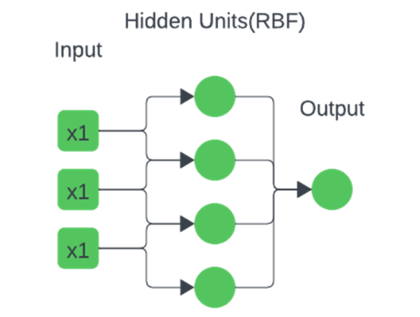
The operation of an RBF Network resembles that of instance-based methods like k-NN, but with a more structured implementation. Here's a step-by-step overview:
- Input Vector – The network takes in a feature vector as input.
- Distance Computation – Each hidden neuron calculates the Euclidean distance between the input vector and its own predefined center.
- Activation Function – This distance is then transformed using a radial basis function, usually a Gaussian, where closer points produce stronger activations.
- Output Calculation – The final output is derived from a weighted sum of these activations, with the weights learned during training.
Key Features of RBF Networks:
- Localized Activation: The output of an RBF neuron is higher when the input is closer to its center.
- Use of Gaussian Function: Most commonly, a Gaussian function is employed as the radial basis function.
- Parameterization: Each neuron is defined by its center and a spread (also called width or sigma).
- Efficient Training: Output weights are learned using straightforward techniques like linear regression.

Structure of an RBF Network:
1. Input Layer:
- Passes input features directly to the hidden layer.
- The number of input neurons equals the number of input variables.
2. Hidden Layer:
- Performs a non-linear transformation using RBFs.
- Each neuron uses a radial function (mostly Gaussian) based on the distance from its center.
- Parameters:
  - Centers: Position in the input space.
  - Spread (σ): Defines how far the influence of the neuron extends.
3. Output Layer:
- Applies a linear combination of the hidden layer outputs.
- The weights of this layer are trained to minimize prediction error.

Training an RBF Network:
Training an RBF network is typically a three-stage process:
Step 1: Center Selection
- Random Selection: Pick centers randomly from training data.
- Clustering Methods: Use clustering (e.g., K-Means) to determine centers that represent data distribution effectively.
Step 2: Spread (σ) Calculation
- The spread determines the radius of influence for each RBF neuron.
- It can be:
  - Uniform for all neurons (constant value).
  - Variable, based on the distribution of centers.
- Heuristic Approach: A common formula is:
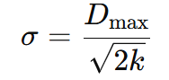
Where D_{max}​ is the maximum distance between centers and k is the number of centers.
Step 3: Weight Optimization
- The final layer's weights are optimized using:
  - Least Squares / Linear Regression
  - Moore-Penrose Pseudo-Inverse – A mathematical method to solve the weights analytically with minimum error.

Applications of RBF Networks:
- Function approximation
- Classification tasks
- Time-series prediction
- System control and robotics
Conclusion:
Radial Basis Function (RBF) Neural Networks are simple yet powerful models for function approximation and classification. They provide fast learning and good generalization but depend on proper selection of centers and spread.

Program:
import numpy as np
from scipy.spatial.distance import cdist
from sklearn.cluster import KMeans
from sklearn.metrics import mean_squared_error

# Generate sample data
np.random.seed(0)
X = np.random.rand(100, 2)
y = np.sin(X[:, 0]) + np.cos(X[:, 1])

# Define the radial basis function
def rbf(x, c, s):
return np.exp(-np.linalg.norm(x - c) ** 2 / (2 * s ** 2))

# Choose centers using k-means
kmeans = KMeans(n_clusters=10, random_state=0).fit(X)
centers = kmeans.cluster_centers_

# Calculate the spread parameter
d_max = np.max(cdist(centers, centers, 'euclidean'))
sigma = d_max / np.sqrt(2 * len(centers))

# Compute the RBF layer output
R = np.zeros((X.shape[0], len(centers)))
for i in range(X.shape[0]):
for j in range(len(centers)):
R[i, j] = rbf(X[i], centers[j], sigma)

# Compute the output weights
W = np.dot(np.linalg.pinv(R), y)

# Define the RBF network prediction function
def rbf_network(X, centers, sigma, W):
R = np.zeros((X.shape[0], len(centers)))
for i in range(X.shape[0]):
for j in range(len(centers)):
R[i, j] = rbf(X[i], centers[j], sigma)
return np.dot(R, W)

# Make predictions
y_pred = rbf_network(X, centers, sigma, W)

# Evaluate the model
mse = mean_squared_error(y, y_pred)
print(f"Mean Squared Error : {mse}")

Output:
Mean Squared Error : 0.02376908712399571

